**Modifying data**

**1.[Insert some data into a table](https://pgexercises.com/questions/updates/insert.html)**

**Query:** insert into facilities (facid, name, membercost, guestcost, initialoutlay, monthlymaintenance) values (9, 'Spa', 20, 30, 100000, 800);

**SQLOUTPUT: **

**2.[Insert multiple rows of data into a table](https://pgexercises.com/questions/updates/insert2.html)**

**Query:** insert into facilities (facid, name, membercost, guestcost, initialoutlay, monthlymaintenance) values (9, 'Spa', 20, 30, 100000, 800), (10, 'Squash Court 2', 3.5, 17.5, 5000, 80);

**SQLOUTPUT:**

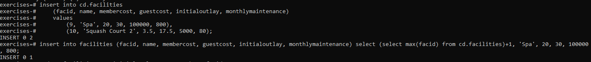

**3.[Insert calculated data into a table](https://pgexercises.com/questions/updates/insert3.html)**

**Query:** insert into facilities (facid, name, membercost, guestcost, initialoutlay, monthlymmaintenance) select (select max(facid) from cd.facilities)+1, 'Spa', 20, 30, 100000, 800;

**SQLOUTPUT:**



**4.[Update some existing data](https://pgexercises.com/questions/updates/update.html)**

**Query:** update facilities set initialoutlay = 10000 where facid = 1; **SQLOUTPUT:**



**5.[Update multiple rows and columns at the same time](https://pgexercises.com/questions/updates/updatemultiple.html)**

**Query:** update facilities set membercost = 6, guestcost = 30 where facid in (0,1);

**SQLOUTPUT: **

**6.[Update a row based on the contents of another row](https://pgexercises.com/questions/updates/updatecalculated.html)**

**Query:** update facilities facs set membercost = (select membercost * 1.1 from facilities where facid = 0), guestcost = (select guestcost * 1.1 from facilities where facid = 0) where facs.facid = 1;

**SQLOUTPUT: **

**7.[Delete all bookings](https://pgexercises.com/questions/updates/delete.html)**

**Query:** delete from bookings;

**SQLOUTPUT: **

**8.[Delete a member from the cd.members table](https://pgexercises.com/questions/updates/deletewh.html)**

**Query:** delete from members where memid = 37;

**SQLOUTPUT: **

**9.**[**Delete based on a subquery**](https://pgexercises.com/questions/updates/deletewh2.html)

**Query:** delete from members where memid not in (select memid from bookings);

**SQLOUTPUT:**

